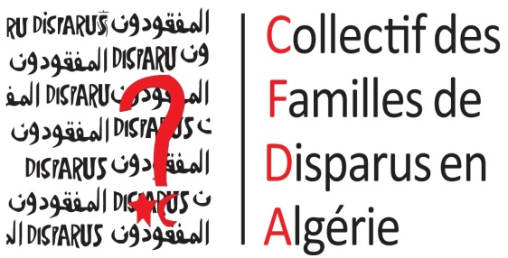

Newsletter n°82

January, february, march 2022

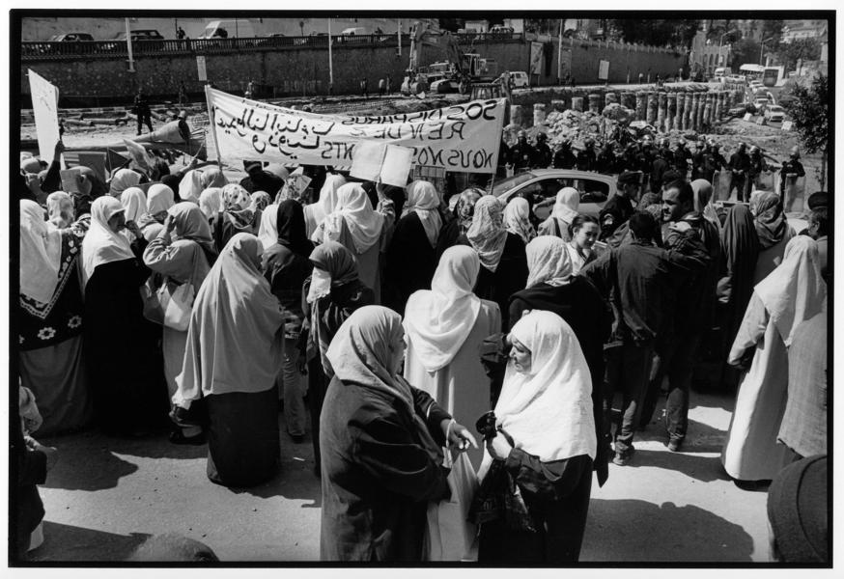

Training on the role of a human rights monitor
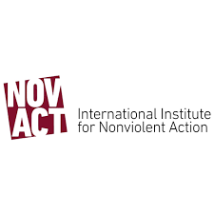
This training, organised by the CFDA on 28 February and 1 March for its teams in Algeria and France, was led by an expert in the field from NOVACT, a Catalan organisation.
During these two days of training, several aspects of monitoring human rights violations were discussed. The training covered two main topics. The first was "how to monitor and document human rights violations in a respectful way, accompanying and being aware of the individual and collective social and psychological impacts of these violations". The second theme was to "define a monitoring strategy and integrate the process of monitoring and data collection into a more comprehensive human rights system". As the majority of the beneficiaries of this training were new to the concept of monitoring, a first point of definition followed by a description of the legal framework of monitoring and the monitor was the subject of discussion during the first day of this training. The second day was devoted to the analysis of practical cases following the notions that were seen the day before and to apply the theoretical knowledge. This training provided participants with a better understanding of the challenges of observation and a broader and more global vision of the repression faced by human rights defenders, with whom the CFDA shares the same values.
Algerian civil society meeting
On 11 and 12 February 2022, the CFDA took part in this meeting initiated by EuroMed Droit, which brought together associations, unions and NGOs working in the field of human rights in Algeria. The agenda of this meeting was to debate on the dramatic situation of human rights in Algeria, especially regarding freedom of expression, freedom of association and women's rights. EuroMed wished to bring together the members and partners of the network on Algeria through a comprehensive discussion of the different themes to identify and explore the different areas of intervention, according to the current priorities of the potential target countries for advocacy, on the one hand, and to consolidate and relaunch the joint initiatives in the coming period, on the other hand. The overall aim was to discuss and validate an action plan to be implemented. To this end, several topics were discussed and debated between the representatives of each association. At the end of the two days, resolutions were taken and a joint statement on hunger strikers and prisoners of conscience was made with the participants.
CFDA joins the Sites of Conscience Coalition
The Sites of Conscience Coalition is an NGO with more than 260 member organisations in 65 countries that works on the duty to remember through various actions such as advocacy missions and training for its members. The CFDA joined this Coalition and participated in an online meeting organised on 22 February 2022. This meeting was an opportunity to welcome the new members, to introduce themselves and above all to explain their expectations in joining this Coalition. Since then, the CFDA has been actively participating in the Coalition's activities.
Arrest of Zaki Hannache: the repression continues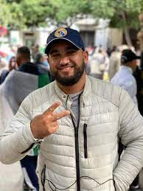

Zaki Hannache, an activist and whistleblower who has been documenting the arrests, trials and conditions of detention of opponents of the current regime since the beginning of the Hirak, was placed in police custody on Friday 18 February 2022 and then placed under a detention order on 24 February 2022. The CFDA and Sos Disparus published a press release to alert and inform on the situation of human rights defenders in Algeria. The number of prisoners of conscience in Algeria is very worrying, with nearly 340 people arbitrarily detained and prosecuted under the pretext of "fighting terrorism" and "preserving national unity", whereas these people, thirsty for freedom, have only expressed themselves peacefully for the advent of the rule of law. For several months, the regime of Abdelmadjid Tebboune has virtually closed the public space and has resorted to systematic mass arrests of Hirak activists, peaceful activists, human rights defenders and trade unionists. While various civil society organisations are being dissolved or threatened with dissolution, and multipartyism seems to be increasingly questioned, the Algerian authorities are seriously undermining freedom of expression, freedom of conscience, freedom of association and freedom from inhuman and degrading treatment.
The CFDA in Geneva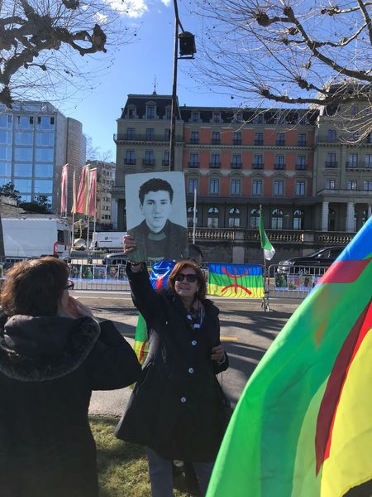
During the month of February, two advocacy missions were organised in Geneva. On 25 February 2022 Riposte Internationale, a human rights NGO, organised a rally in front of the United Nations Palace in Geneva. About fifty people participated, speeches, songs and slogans were shouted to, once again, alert the public to the critical situation in Algeria. Finally, on 11 March 2022, Riposte Internationale and the CFDA met with the MMO officials of the Office of the High Commissioner for Human Rights of the United Nations in order to transmit to them reports that had been drawn up by their associations.
The CFDA presents its report on the failure of the rule of law in Algeria

On 17 and 18 March, the CFDA, accompanied by the association Riposte Internationale, carried out an advocacy mission in Brussels to present its report on the judicial system in Algeria. This report, entitled "Justice in Algeria: the failure of the rule of law", as well as the report on serious human rights violations presented by Riposte Internationale, were the subject of advocacy documents presented to various actors such as officials of the European Parliament, officials of the European Commission, MEPs and diplomats at the European Union.
This advocacy mission is part of the CFDA's missions around the following themes: the fight against impunity, the right to truth and justice for the families of the disappeared, the right to freedom of expression and information, the right to freedom of association and the right to freedom of assembly and demonstration. Several alarming points about the situation in Algeria were discussed with the people we met. We were able to raise the issue of prisoners of conscience and to alert them to the arbitrary nature of their detention conditions. We also discussed the serious and constant human rights violations in Algeria and the intensive repression by the Algerian state.
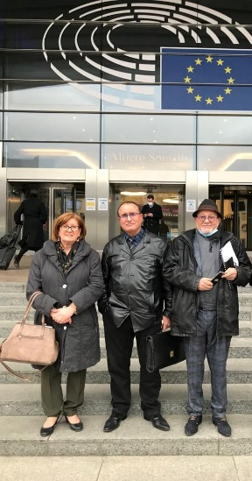

Finally, we were able to make several recommendations, such as the establishment of a transitional justice process in Algeria, because amnesty laws such as the Civil Concord or, more recently, the Charter for Peace and National Reconciliation deprive Algerians of their rights. The serious human rights violations that have taken place and are still taking place cannot continue to go unpunished by the Algerian state, which continuously tramples on the fundamental rights of its population. The transitional justice process brings Truth, Justice, Reparations and the guarantee of non-repetition that all victims and relatives expect. Without the respect of these four pillars, Algerian society will not be able to rebuild itself peacefully and sustainably. Other recommendations include the establishment of a Truth and Reconciliation Commission (TRC) and the repeal of the texts implementing the Charter. This advocacy mission to Brussels, together with representatives of the human rights NGO Riposte International, was very fruitful.
The Universal Periodic Review (UPR)
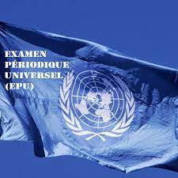
The Universal Periodic Review (UPR) is a periodic review of the human rights achievements of all 193 UN States. It gives all States the opportunity to declare the measures they have taken to improve the human rights situation in their country and to overcome obstacles to the exercise of these rights. The CFDA and Sos Disparu(e)s mobilised very early on in the process of this review in order to draft an alternative report in a collegial manner with various actors in Algerian civil society (associations, NGOs, human rights defenders, researchers working on questions of social justice, democracy, the rule of law and respect for human rights, etc.). This report was submitted to the Office of the High Commissioner for Human Rights in Geneva so that all the recommendations made regarding the human rights situation in Algeria could be taken into account.

BRIEFS

Press release following Abdelmadjid Tebboune's statements
On 19 March 2022, in a message to mark the anniversary of the ceasefire of the War of Independence, Algerian President Abdelmadjid Tebboune called for 'efforts to be continued to shed light on the fate of the disappeared during our war of liberation'. As the year 2022 marks the sixtieth anniversary of Algeria's independence, the Algerian government wishes to continue its efforts to honour the memory of Algerian fighters and resistance fighters. The Collectif des Familles de Disparu(e)s en Algérie and SOS Disparus welcome this step and express their attachment to Truth and Justice but Truth and Justice.
Online training on negotiation skills in an advocacy context
An online training course was organised by the EuroMed network; members of the CFDA and Sos Disparus were able to participate. During two days, the trainer Kerim Bouzouita focused on negotiation techniques in advocacy techniques. Different techniques were seen and used afterwards during the case studies. As some people from CFDA and Sos Disparus were new to this practice, this training broadened their field of competence. These two days of training provided a significant theoretical basis for putting these techniques into practice during advocacy missions within national and international bodies.

Press review :

January
Revue-de-presse-Janvier-2022.pdf (algerie-disparus.org)

February
Revue 02-22.docx (algerie-disparus.org)

March
Revue 03-22.docx (algerie-disparus.org)

Sos Disparu(e)s – Sos Disparu(e)s – Sos Disparu(e)s – Sos Disparu(e)s – Sos Disparu(e)s Sos Disparu(e)s – Sos Disparu(e)s Disparu(e)s – Sos Disparu(e)s – Sos Disparu(e)s

Contacts

Email : cfda@disparus-algerie.org
Website : www.algerie-disparus.org
Phone : +33 9 53 36 81 14

Notre page Facebook
Sos Disparu(e)s – Sos Disparu(e)s – Sos Disparu(e)s – Sos Disparu(e)s – Sos Disparu(e)s Sos Disparu(e)s – Sos Disparu(e)s Disparu(e)s – Sos Disparu(e)s – Sos Disparu(e)s

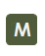
Notre Mémorial Virtuel

